Day 1 Assignment..

**Concat and slice program**

**a="pyhton"**

**b="programming"**

**print(b+""+a,"\n") #concat a string..**

**print(b[:5],"\n")#slicing a string from first 5 character..**

**print(b[2:5],"\n") # slicing a string between giving value**

**print(b[3:],"\n") #slicing frist 3 character from string**

**print(a[-4:-1],"\n")**

**print("\n getting first 3 character",b[:3])**

**print("\n getting last 5 character\n",b[5:])**

**……………………………………………………………….**

**Average calc**

**a=int(input("\n enter value a"))**

**b=int(input("\nenter value b"))**

**c=a+b**

**print("\n total value of a and b",c)**

**d=c/2;**

**print("\n average value",d)**

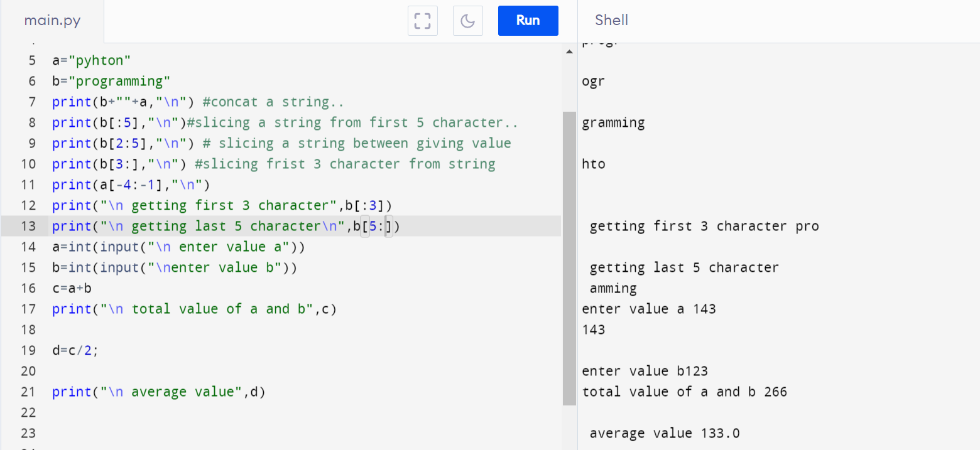

Day 2 Assignment

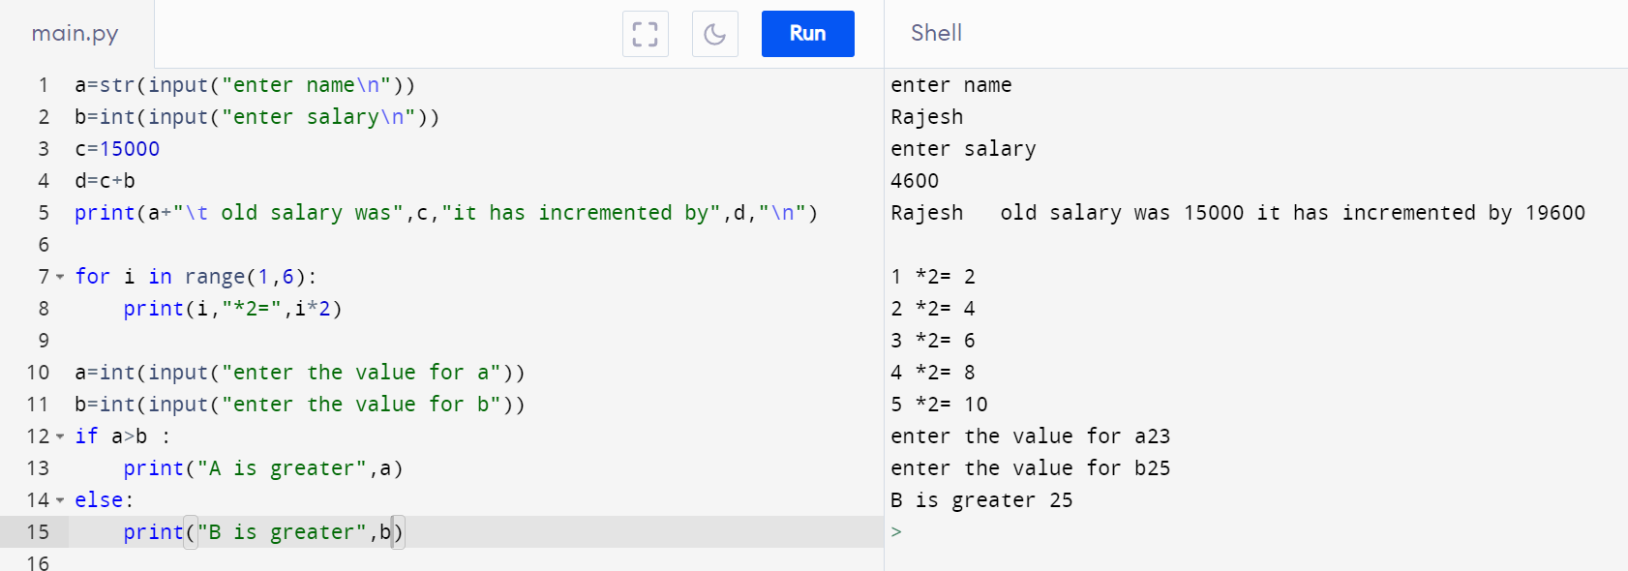

a=str(input("enter name\n"))

b=int(input("enter salary\n"))

c=15000

d=c+b

print(a+"\t old salary was",c,"it has incremented by",d,"\n")

……………………………………………………..

For loop example

**for i in range(1,6):**

**print(i,"*2=",i*2)**

………………………………………………………

If statement..

**a=int(input("enter the value for a"))**

**b=int(input("enter the value for b"))**

**if a>b :**

**print("A is greater",a)**

**else:**

**print("B is greater",b)**